Temperature reading and sanitizing is MANDAOTRY before entry.
Masks are ALWAYS to be worn completely covering your nose and mouth inside of the facility (no exceptions).
Please pay attention to any physical guides, such as tape markings on floors or signs on walls and direction from Ushers to remain at least 6 feet apart from each other.
Allow other people 6 feet of space when you pass by them.

Why practice social distancing?
COVID-19 spreads mainly among people who are in close contact (within about 6 feet) for a prolonged period. Spread happens when an infected person coughs, sneezes, or talks, and droplets from their mouth or nose are launched into the air and land in the mouths or noses of people nearby. The droplets can also be inhaled into the lungs. Recent studies indicate that people who are infected but do not have symptoms likely also play a role in the spread of COVID-19. Since people can spread the virus before they know they are sick, it is important to stay at least 6 feet away from others when possible, even if you—or they—do not have any symptoms.

What you need to know
- Stay home if sick.
- Wear masks in public settings and when around people who don’t live in your household, especially when other social distancing measures are difficult to maintain.
- Use social distancing (stay at least 6 feet away from others).
- Before you go, call and ask what extra prevention strategies they are using, like requiring staff to wear masks.
- Wash your hands with soap and water for at least 20 seconds when you get home.

Evidence for Effectiveness of Masks
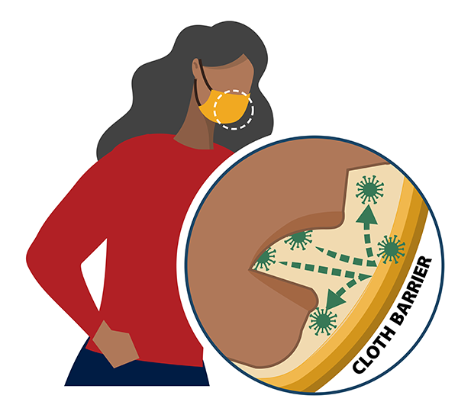
Masks are recommended as a simple barrier to help prevent respiratory droplets from traveling into the air and onto other people when the person wearing the mask coughs, sneezes, talks, or raises their voice. This is called source control. This recommendation is based on what we know about the role respiratory droplets play in the spread of the virus that causes COVID-19, paired with emerging evidence from clinical and laboratory studies that shows masks reduce the spray of droplets when worn over the nose and mouth. COVID-19 spreads mainly among people who are in close contact with one another (within about 6 feet), so the use of masks is particularly important in settings where people are close to each other or where social distancing is difficult to maintain.

